Book Times.
Story times or “book times” are extremely important both in school and at home. It’s a chance for the class or family to spend some time together doing something which everyone can enjoy. Reading aloud to the class is the most important thing that we do at Medlock each day. During this protected time, the children experience a range of stories, poems and challenging non-fiction texts that they may not otherwise encounter. Each class receives at least one story time a day.
Remember to check your class’ Seesaw page for additional storytime sessions that can be shared at home.
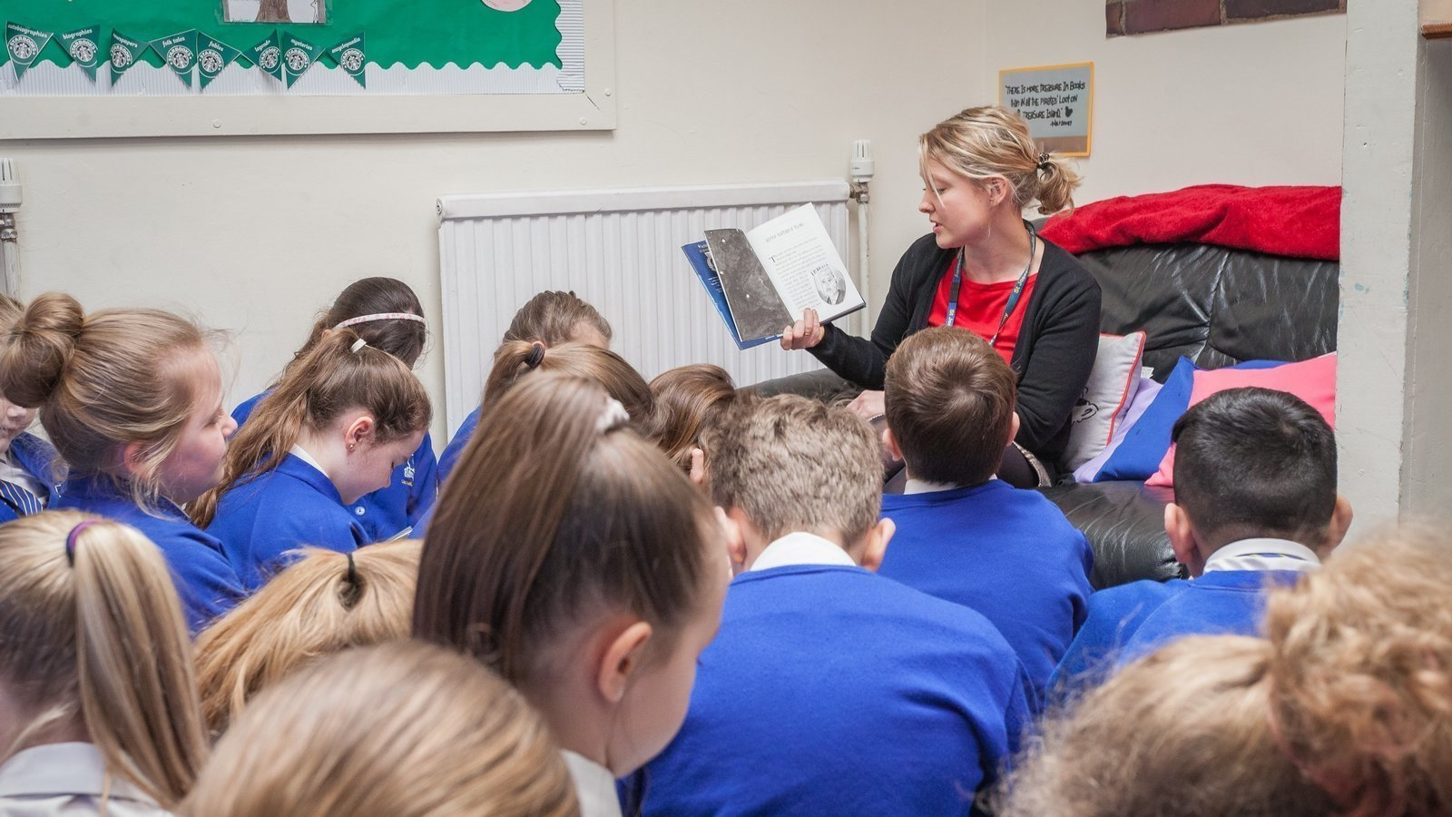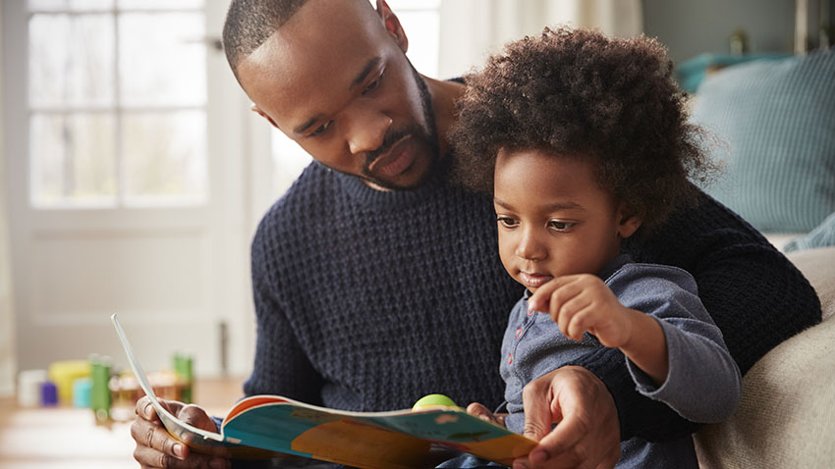
Below are some links of stories you can share as a family at home:
CBeebies Radio Story Time
FREE eBook Library from Oxford Owl for Home
Stories for kids online and fun games to play | BookTrust
War Horse - Chapter 1 by Michael Morpurgo Matilda by Roald Dahl - Theatre Collection https://www.youtube.com/watch?v=RL8Ymj594tc&list=PLQwRP1x5nD7aXUz9zxLaLffw-Wrmok1-4 David Walliams’ Gangster Granny

