Local Libraries.
We’re really lucky in Manchester because we have lots of libraries where we can borrow books for free! Look which library is your closest below and visit them to get a free library card to get books out for free.
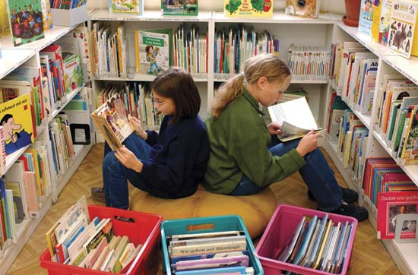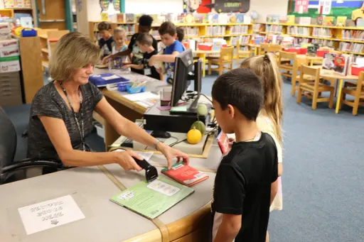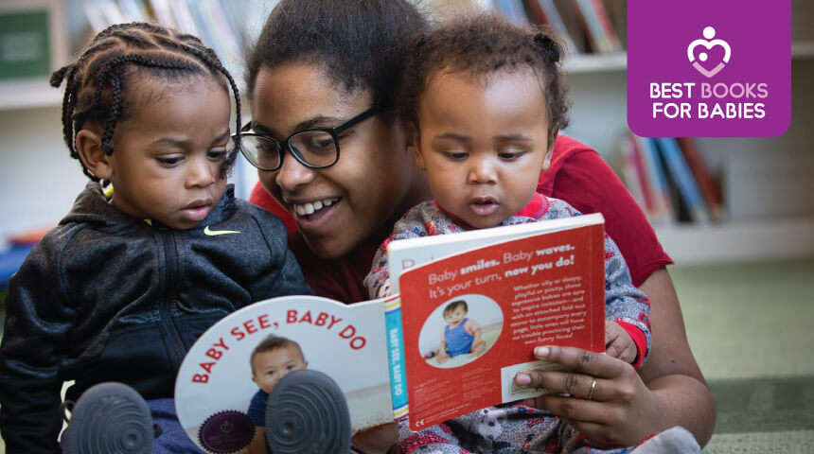
Central Library, city centre, M2 5PD. Open every day 10-4pm apart from Friday and Sunday.
Arcadia Library, Levenshulme, M19 3PH. Open Monday-Saturday 11-3pm.
Longsight Library, Longsight, M12 4NE. Open, Tuesday, Thursday, Saturday 11-3pm.
Hulme High Street Library, Hulme, M15 5NN. Open Monday and Saturday 11-3pm.
Some of the libraries even have free clubs that you can attend too…
From Central Library, St Peter’s Square you can even borrow musical instruments! There’s also a free Lego club every Saturday 2-4pm and a coding club every Thursday 5-6pm.
Arcadia Library in Levenshulme even has
a swimming pool! Every Thursday from 3-4pm they also have a free colouring club.
Longsight Library runs a story time for under 6s every Thursday from 2-2:45pm.

