Book Reviews
At Medlock we love reading!
Here are a few of our favourite books!
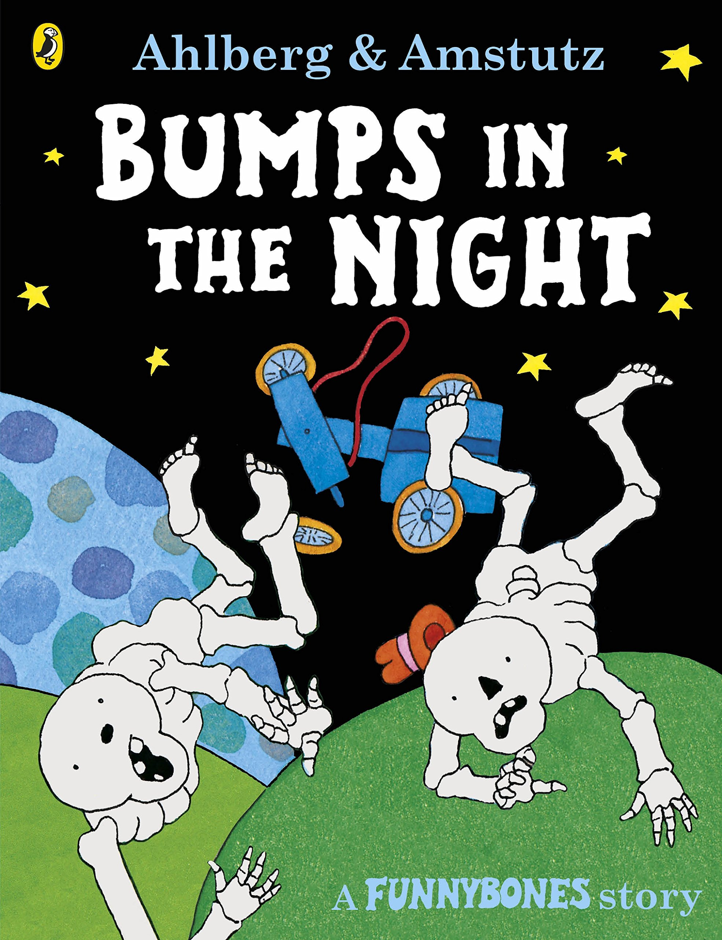 “They bump a lot of times and it’s really funny!” Mihaz, Year 1.
“I love crocodiles and they eat people up!” Mervin, Nursery. 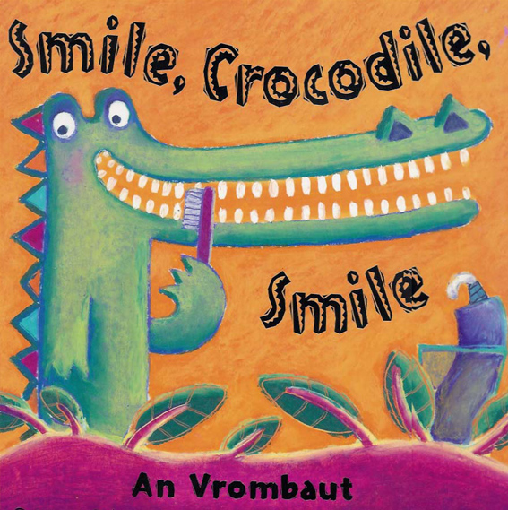
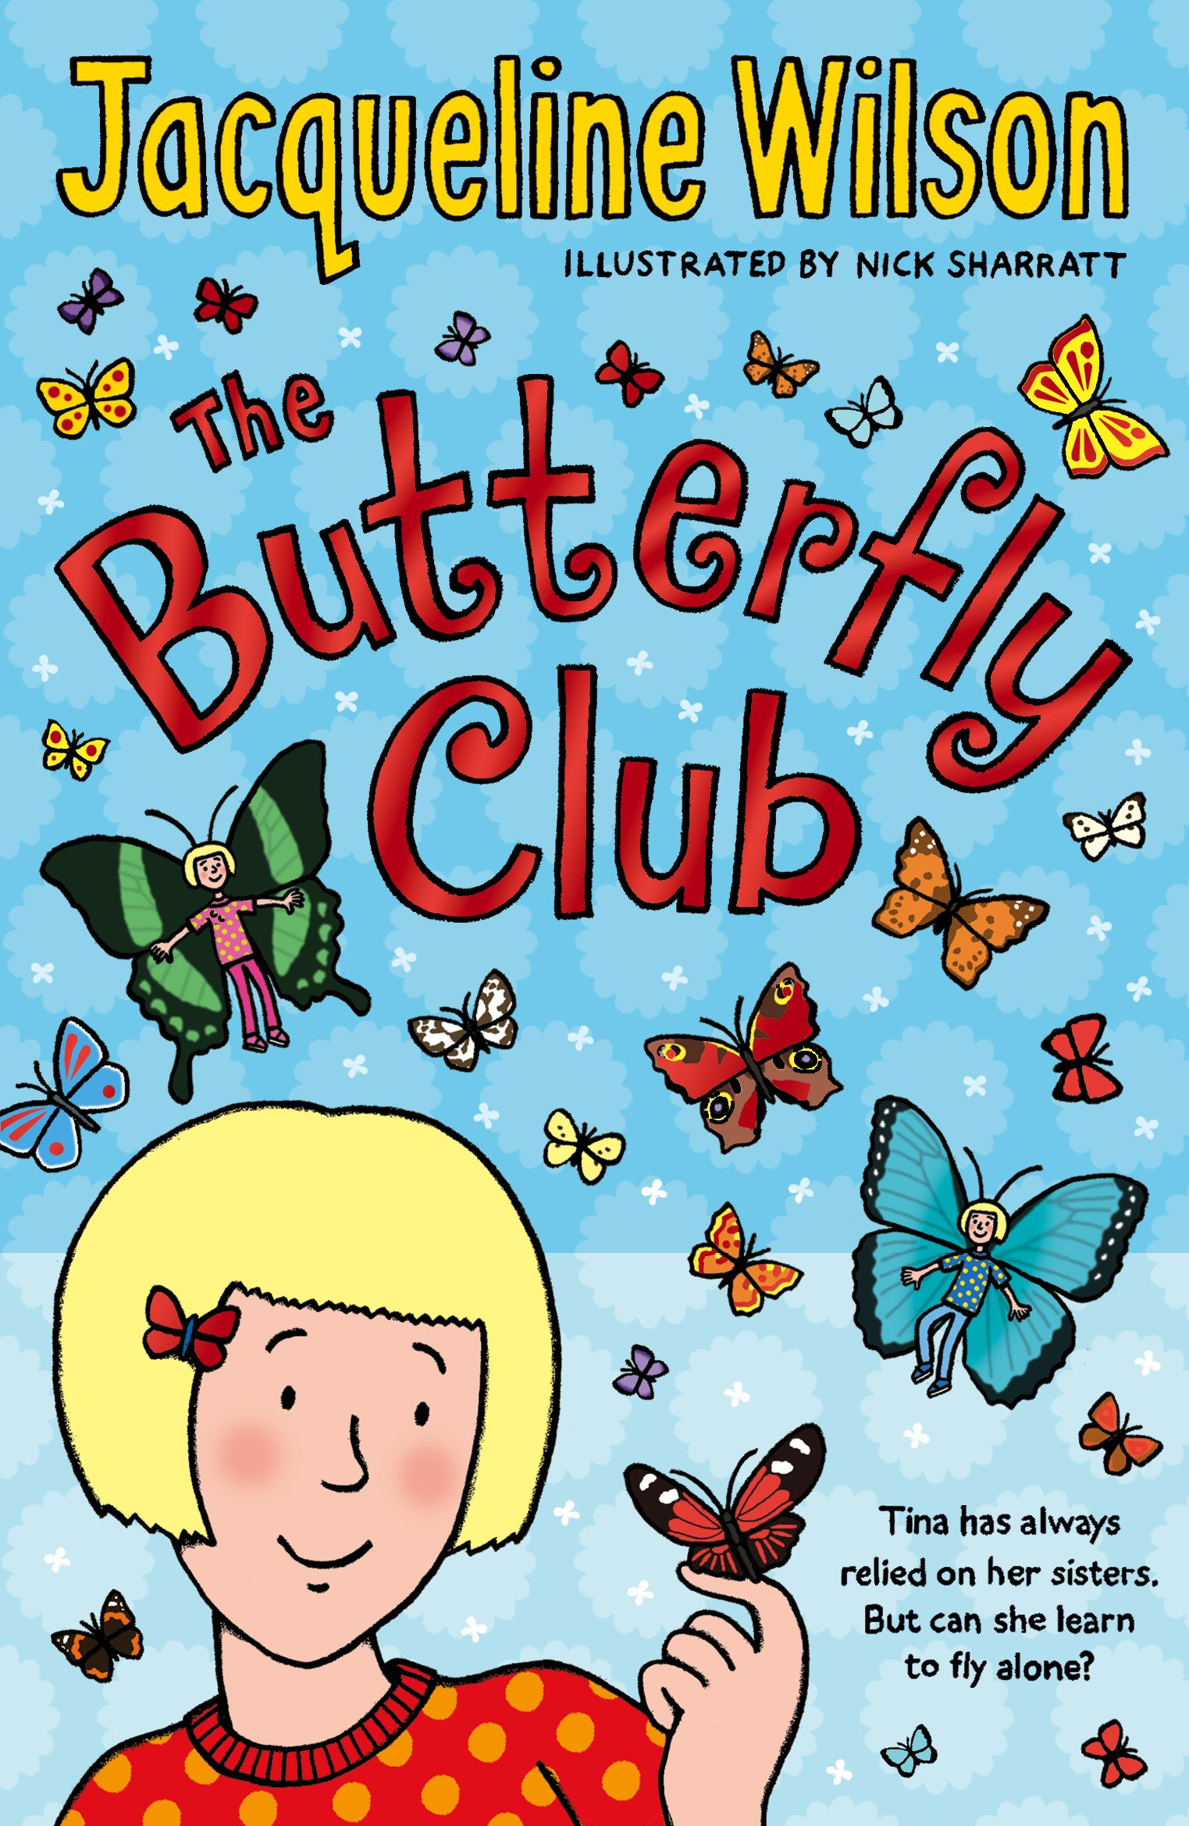 “This book gives you advice like how to make your own butterfly garden” Ruqayyah Year 4.
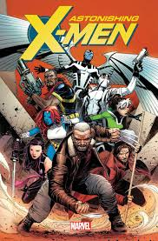”I love it when the characters come together and fight the X-men, they work as a team!” Ray, Year 5.
“I love this book because of the beautiful illustrations!” Miss Samdani. 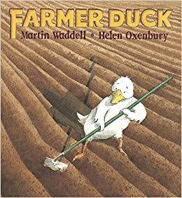

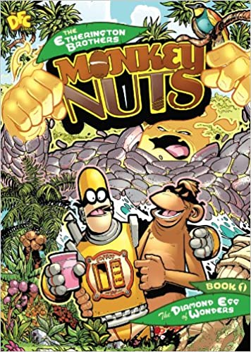”It’s a comic book which I love and they go on lots of adventures!” Joseph, Year 3.

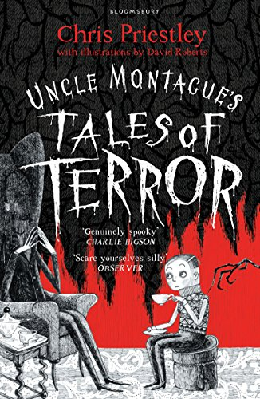”It’s creepy… a boy’s on a train and his step-mother has a dream which comes true! It’s really spooky!” Yaseen, Year 6.
“I love how creative and imaginative the author is!” Miss White.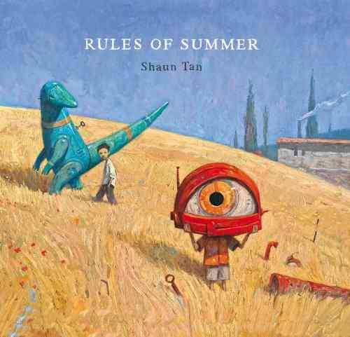

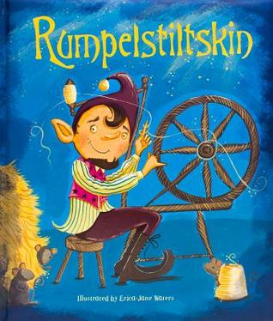 “I love the princess because she has a pretty crown!” Maryam, Year 1.

